South Carolina Immigration Law & Possible Consequences

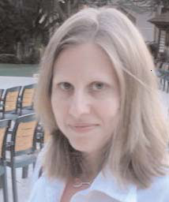

Tammy Besherse
Staff Attorney
SC Appleseed Legal Justice Center

September 4, 2008
4:00pm

Russell House
Room 315

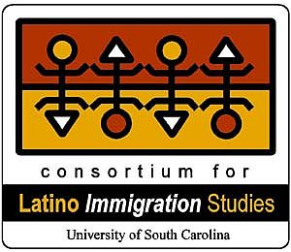
Sponsored by the Consortium
for Latino Immigration Studies

